**Lab Exercises**

1. Consider to roll two dice at the same time. There are 36 possible outcomes of these rolls, and all are equally likely. Here is the sample space when two dice are rolled.

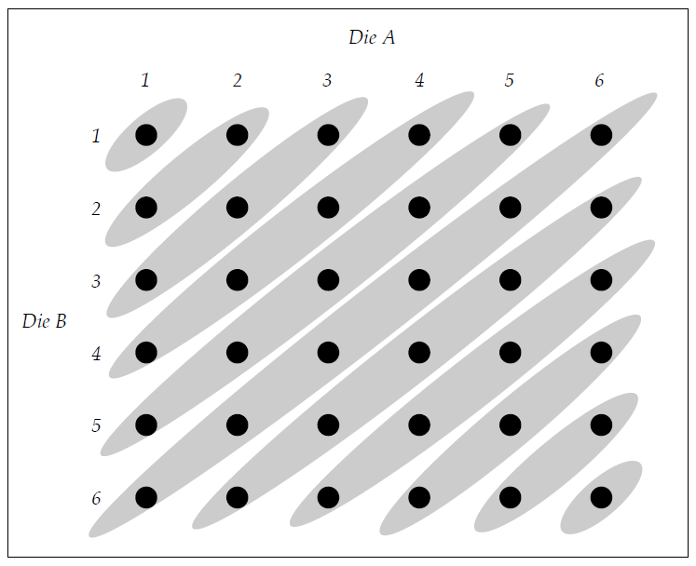

There are 11 possible values for the sum of two dice, as the above figure.

Now, you are asked to compute the probability that the sum of the dice is 6, given that the first die gives a value that is ≤ 3. You should use both of the following ways separately to solve the problem:

* 1. Conditional probability
  2. Bayes’ Theorem

1. Suppose you are asked to study the relationship the average examination mark and the completion of the lab exercises of a Python programming class. 60% of the students in the class complete all the lab exercises. Among the students who have completed all the lab exercises, their mean examination mark is 70 with a variance of 5. On the other hand, the mean examination mark of the students, who have not completed all the lab exercises, is 55 with a variance of 10.

Create a model in Pyro with a simple stochastic function that describes how 30 sample examination marks can be generated.

1. Imagine that you have a body scale that helps you keep track with your body weight. However, the scale is quite old and is not very accurate. Each time you use the scale to measure your body weight, it gives you a slightly different measurement. But, those measurements form a *normal distribution* around your *true weight* with a *standard deviation* of 1.5 kg.

Create an *inference* model in Pyro *to find a suitable estimate for your body weight* based on the following observations:

61.5, 67.0, 63.6, 62.4, 66.8

**\*\*\* End of Lab 5 \*\*\***